**Lecture 25 – Nervous System**

In this lecture, you will learn about how nerve impulse is transmitted through the nervous system. You will also learn about the form and function of the central nervous system.

* Nervous system handles information processing.
  + Our body detect stimuli (sensory input) through ( ) neurons in the sensor, and the signal is transmitted through ( ), which analyze, interpret information, and make decision, and then the resulting signal travel through ( ) neurons which communicate with effector cells.
  + Central nervous system consists of brain and spinal cord.
  + Peripheral nervous system consists of all the nerves out of spinal cord connecting to organs.
* Sensory system responds to both external and internal stimuli.
  + External stimuli:
  + Internal stimuli:
* Neuron receives and transmits information. Know the structure of the neuron (Fig. 48.4).
  + Neuron consists of ( ), ( ), and ( ).
  + ( ): junction where chemical information (neurotransmitter) is passed on
  + Signals travel through axon via ( ).
* ( ) provides electrical insulation. (Fig. 48.13)
  + Produced by glial cells (Schwann cells and oligodendrocytes)
  + Nodes of Ranvier: gaps in the myelin sheath that result in ( ) (fast signal conduction)
* All cells have a membrane potential (voltage) across plasma membrane.
  + Non transmitting neurons have a ( ) potential between -60 and -80 mV (millivolts) – they have a ( ) charge
* ( ) potential is the electrical potential generated by ion differential across membrane (Fig. 48.7).
  + (Potassium) ions and (sodium) ions play an essential role in forming resting potential.
  + At resting potential, the concentration of () ions is high inside neuron cell, and the concentration of ( ) ions is high outside neuron cell.
* Changes in the membrane potential occur because neurons contain gated ion channels.
  + K = Potassium
  + Hyperpolarization: opening (K+) channels increases permeability to (K+) 🡪 net diffusion of (K+) out of neuron 🡪 inside neuron becomes more (negative)
  + Depolarization: opening (Na+) channels increases permeability to (Na+) 🡪 net diffusion of (Na+) out of neuron 🡪 inside neuron becomes more (positive)
  + Action Potential: Deploraization reaches the threshold 🡪 opens most Na+ channels (K+ channels remain closed) 🡪 massive influx of Na+ into neuron
  + Depolarization reaches the threshold 🡪 opens most () channels (potassium channels remain closed) 🡪 massive influx of () into neuron
* You should know how action potential works (Fig. 48.11).

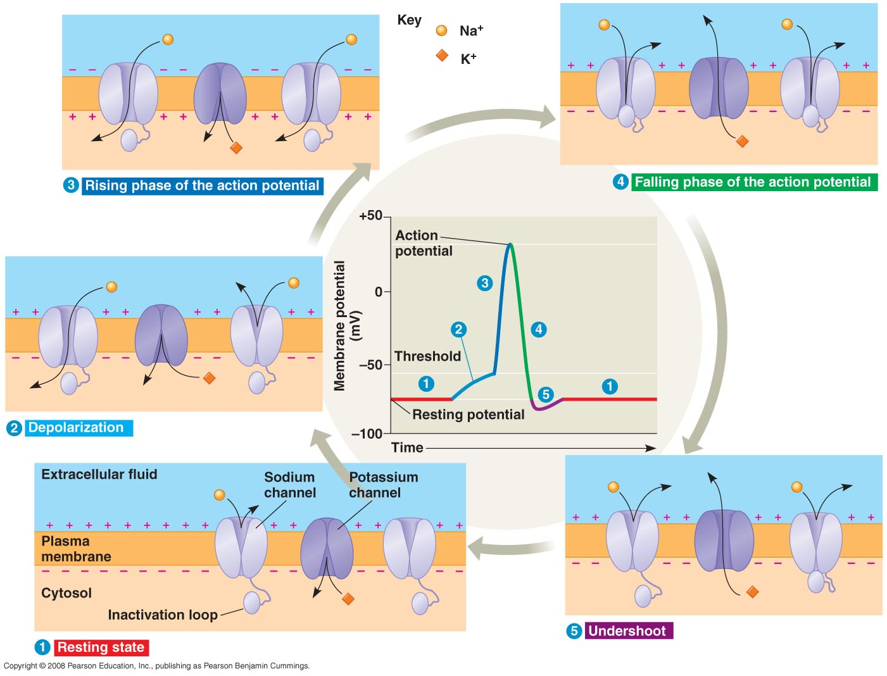

* Action potentials are conducted in a cascade-like manner along axons (Fig. 48.12).
  + Depolarization of the action potential spreads to (neighboring region).
  + The previous membrane gets (repolarized).
  + (Refractory period) period: membrane cannot be re-stimulated – prevents potentials from traveling backwards.
* Nervous system involving neurons evolved about 500 million years ago.
* Central nervous system (CNS) consists of (brain) and (spinal chord).
  + Brain provides integrative power.
    - (Gray) matter: neuron cell bodies, dendrites, unmyelinated axons
    - (White) matter: bundled axons with myelin sheaths
    - Ventricles: filled with cerebrospinal fluid (supply nutrients and hormone, carry away wastes)
  + Spinal cord conveys information to and from brain, generates basic patterns of locomotion, and produces reflex
    - (): the body’s automatic responses to certain stimuli. Example:
      * Infant grasping, knee-jerk reaction
* Peripheral nervous system (PNS) regulates movement and internal environment.

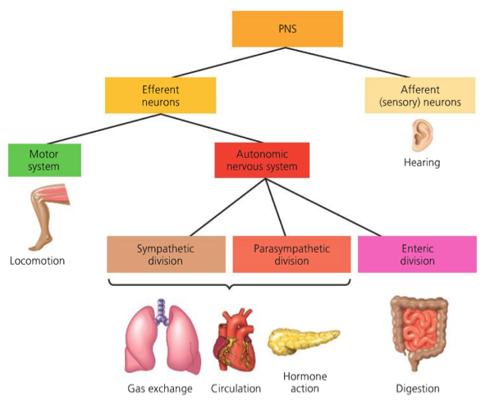

* Human brain differentiates into specialized region during development. Read Figure 49.9 (p. 1068-1069) to get a better understanding of the organization of human brain.

** Know all the adult parts of the brain **

* Human brain has four major parts.
  + **Brainstem** is the site for (homeostasis).
    - (Midbrain) receives and integrates sensory information.
    - (Pons) and (medulla oblongata) transfer information between PNS and midbrain, control automatic homeostatic functions (breathing, heart activity, digestion)
  + (Cerebellum) is important for coordinating motor control.
    - Coordinate movement, balance, help learning, remember motor skills
  + **Diencephalon** is a relay station for information flow in the body.
    - (Thalamus): main input center for sensory information going to cerebrum
    - (Hypothalamus): important region for homeostasis, sexual behavior, fight-or-flight response, pleasure
    - (Epithalamus): pineal gland, source of melatonin
  + (Cerebrum) controls muscle contraction, learning, emotion, memory and perception.
    - Site of information processing
    - Cerebral cortex divided into left and right cerebral hemispheres and connected by (corpus callosum).
  + Cerebral cortex is the site for information processing (Fig. 49.15).
    - Frontal lobe: speech, motor-cortex
    - Temporal lobe: Smell, Hearing,
    - Parietal lobe:
    - Occipital lobe:
  + Neurons are arranged according to the part of the body that generates the sensory input (Fig. 49.17).
    - Motor cortex:
    - Somatosensory cortex: